**Exp No:18**

**Date:**

**DATABASECONNECTIVITYUSINGPHP AND MYSQL**

**AIM:**

To connect the Mysql using PHP and MYSQL and to execute the CREATE, INSERT, SELECT command in MySQL

**PROGRAM:**

<?php

$host=

$password=””;

$conn=mysqli_connect($host,$user,$password);

if(!$conn)

{

Die(‘couldnot connect:’,mysql_connect_error());

}

echo”connectsuccessfully(‘br/>’)”;

$sql=’Create database mydb’;

$sql="create table emp(id int,namevarchar(10) NOT NULL,empsalary INT NOT NULL,primary key(id))";

$sql=”insert into emp(id,name,empsalary) values(312,RANA,200000)”;

$sql=”delete from emp where id=1”;

$sql=”updateemp set empsalary=9000000 where id=312”;

if(mysqli_query($conn,$sql))

{echo ”operations failed failed”,mysqli_error($conn);

}

mysqli_close($conn);

**?>**

**OUTPUT:**

After creation of database and emp table



After insertion:

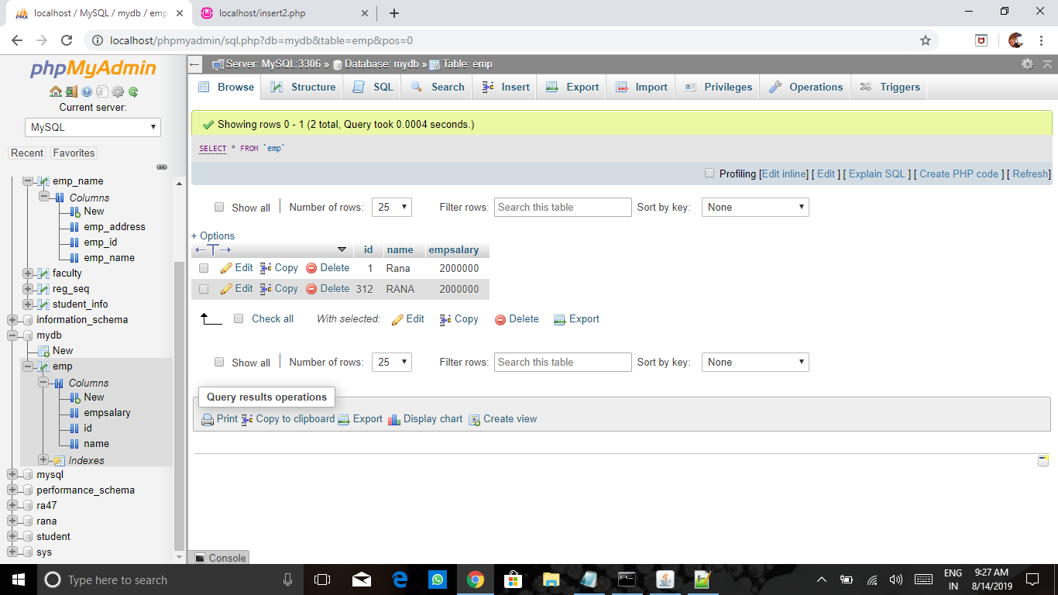

After deletion:

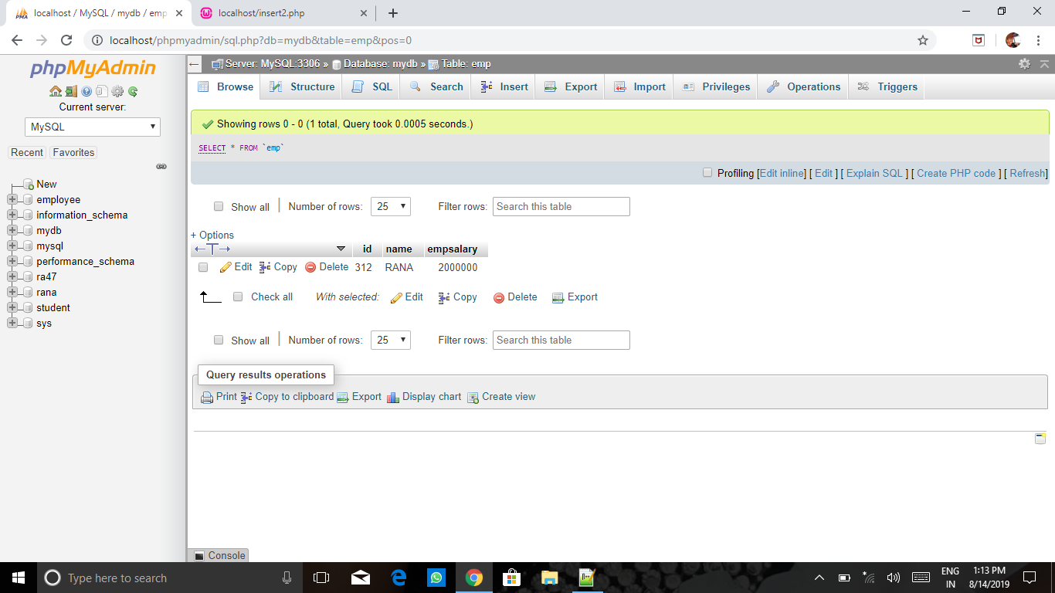

After updation:

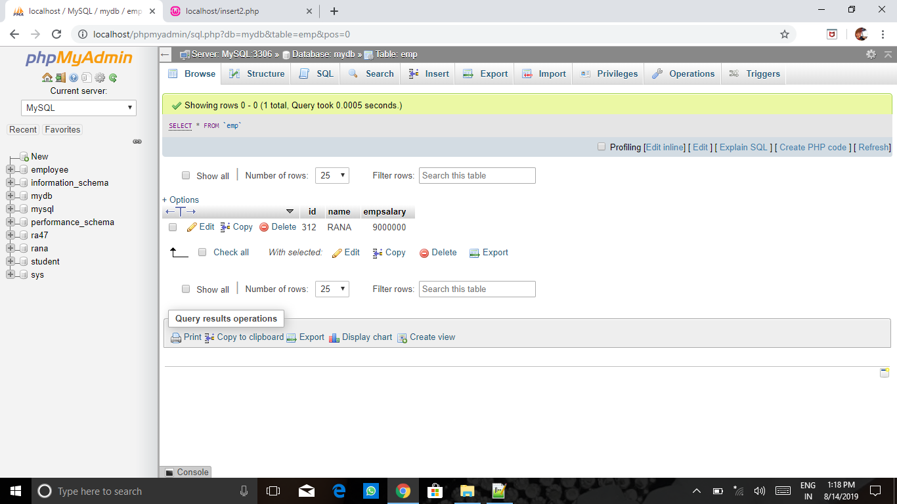

**RESULT:** Thus the Mysql connected using PHP and MYSQL and executed the CREATE, INSERT, SELECT command in MyQL.